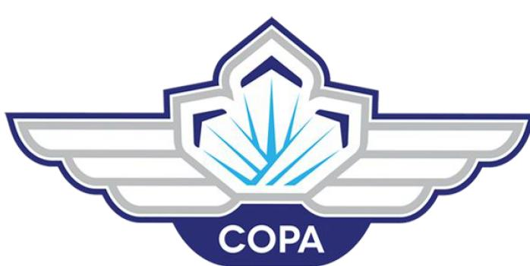COPA Discover Aviation 2022

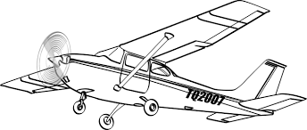

Flights scheduled starting 9:00 Saturday Sept. 10, 2022
Please click on this form to register. Or cut and paste this https://form.jotform.com/222366347450253

The Registration link also has the authorization and waiver.

Please arrive 20 minutes early to allow time for check-in and waiver forms.

What to expect:
COPA Discover Aviation Program is to provide a motivational aviation experience, focusing on an introductory flight in an aircraft. These flights are provided free of charge by members of the local chapters of COPA (COPA Flights) to any motivated youth aged 8 to 17 inclusive. Drayton Valley COPA 186 is hosting this event.

First check-in, waiver check. Then a ground school teaching the basics of flight. There will be a pilot there to talk about a Career in Aviation. Next each will get to meet their pilot for a flight.
Have you always wondered what it’s like to fly? The COPA Discover Aviation Program has been developed to welcome our friends, community-members and future pilots into the world of aviation by providing a free discovery flight in a small airplane and in encouraging interest to join Canada’s growing flying community.
Aviation is exciting and can provide once-in-a-lifetime experiences. As a “pilot for a day” you’ll experience an enjoyable flight that may give you a new perspective on the world. The discovery flight will be conducted according to federal regulations. In addition, no aerobatic maneuvers will be performed.
About COPA
COPA is the hosting body of the COPA Discover Aviation events happening all across Canada. We represent nearly 15,000 pilots and 200+ chapters (known as COPA Flights) located in all 10 provinces and one territory. Our members are aviation enthusiasts of every age group, including many airline and commercial pilots, engineers, business people–even astronauts. They enjoy all types of aircraft, including experimental machines, drones, fixed-wing aircraft, gliding planes, helicopters, and floatplanes.
About Magnes
The Magnes Group is a proud exclusive sponsor for the COPA Discover Aviation Program. They are a privately owned and operated Canadian company and offer insurance and risk management solutions in keeping with their clients’ financial goals. Service and responsiveness are core to their delivery and their independence ensures the autonomy to always act with the clients’ best interests in mind.

Who are the pilots?
The pilots participating in the COPA Discover Aviation Program are local members of COPA who are volunteering their time and aircraft to make your discovery flight possible. Each COPA Discover Aviation pilot is licensed by Transport Canada and all the aircraft utilized meet the regulatory requirements to safely fly you and your loved ones. Only current COPA members are covered under the Air Meet Insurance (non COPA members who wish to participate in the event do so at their own risk and expense and COPA assumes no liability). Members of COPA Flights (proof of membership required) that hold a current COPA Corporate membership are covered under the COPA Air Meet Insurance.
Who can participate?
Anyone 8 years of age and old can become a pilot-for-the-day with COPA. We do require all participants to complete a consent waiver given to them by either the COPA Flight hosting the COPA Discover Aviation event or the COPA member providing the individual discovery flight.
How do I participate?
There are two ways to become a pilot-for-the-day with COPA:
- Find a COPA Discover Aviation event and register for a discovery flight – check out our events calendar here
- Find a current COPA member who will provide you a personal discovery flight

Procedures at Airport When Participants Arrive
- Registration Table. Fill in waiver
- Check name off Manifest (Fly List). Registration staff will Check Manifest- We need record which pilot each guest flys with.
- Get Name Tag for each person who will fly and has completed waiver.
- Ground school.
- Wait for Guide to call name and take you to meet your pilot.
- Pilot will check waiver, then board aircraft.
- FLY. Yahoo!!
- After flight, Guide will meet Pilot with Certificates and participant package.
- Pilot will sign certificates, and present participant package.
- Age 8 to 13 receive Foam airplane, and
- 14 - 17 receive logbook. Pilot can help with first entry in log book. (You will be contacted by Haangar for free ground school, after we send in the completed manifest.)

Pilot
- Get introduced to participant by regristration.
- Check waiver, but leave them with registration. Take certificate to sign and give out after flight.
- Safety Briefing (Link to Pilot Briefing /Flight Route)
- Follow discussed flight plan
- At end of flight sign Certificates and give to participant.
- Sign Certificate
- Present Certificate to Participant. (Mom wants a picture of this!)
- Smile and start again!

Guides- Safety Vest Needed
- Get waiver from Registration for the next flight. Each Plane/ Pilot will have a folder.
- Find the participants for your flight.
- When Pilot is ready, walk participants to meet pilot.
- Introduce kids to Pilot.
- Show Pilot the waiver, but keep them in folder.
- Return waivers to registration.
- Get Certificates in exchange for waivers. Also Participant package for each according to age.
- Watch for plane to return.
- ** Optional** If parents want a photo opportunity, walk with them to meet plane.
- Meet Pilot with the certificates and participant packages.
- Pilot will sign Certificate and present to Participant.
- Guide will Walk with participant/ parents back to safe area.
- Smile, Go to registration and do it again.

Registration- for participant

Greet Each Participant as they arrive to your table.
- Verify waiver complete and signed both sides.
- Check name on Manifest, or add them if not there.
- Send them to Ground school.
- Assign Waiver to a specific pilot/ flight folder.
- Give next flight to pilot for that plane.- Pilot will take participants to plane, but leave signed waivers at registration desk.

Certificates Trader and Waiver filer
- Receive folder from guides after takeoff.
- Exchange waivers to personalized flight certificates
  - Fill in Flight Certificate all details but pilot signature.
  - Write certificate names pretty
  - File Waivers
- Put Participant package and certificates in folder
- Give folder of Certificates to Pilot to sign and give out after landing.

Ground School
- Teach Copa Flight and safety basics.
- Discuss Career in Aviation

Before Event
- Sign up online (Form on JotForm)
- Print Manifest (list of names) (Alphabetically per time slot). We need record pilot with guest, and send to COPA after event.
- Print up Name Tags

COPA for Kids Positions

Planning and Organiser- Jerry Greiner

Flight Supervisor - ________________

Registration
Registration Leader | Rachelle Greiner
Registration
Certificate Filler, Trader & Waiver Filer
Ground School Teacher
Guides

Pilot Name | Aircraft Make | Call Sign | Number of Passengers
Jerry Greiner 780-621-2555 | Stinson S-108 | CF-EXK | 3
Jason Colby | Cessna 172 | C-FBVT | 3
Jim Kalan | Cessna 172 | C-GKAA | 3
Corey Howatt | Cessna 185 | C-GEHJ | 3
Rick Borgen | Cessna 182 | C-FRBE | 3
Chris Berkley 780-405-6379 | Gyroplane RAF 2000 | C-GEDF | 1
John Pridie | Gyroplane RAF 2000 | C-FIZZ | 1
Michael Bellamy  780-499-3363 | Morrisey 2150A | C-GFHZ | 1

Registration Email sample
I sent this email to each
Subject: COPA Discover Aviation Flights Saturday Sep 10 DV Airport.
Hi (Parent’s first name)___________,
_(Child’s name)__________ is registered in the 9:30 group.
Thanks for registering your child for the Discover Aviation Flights Saturday Sept. 10 at the DV Airport.
Flights are planned in 2 groups, at 9:30 and 10:30, with several planes flying. Please arrive 20 minutes early to allow time for check-in.

Jerry Geriner
Pembina Regional Aerodrome Association, COPA Flight 183
Email greiner.jerry@gmail.com
Cell 780-621-2555

Pilot Briefing / Flight Route
See Link Here Sample on next page.

